***Dt : 6/9/2022***

***faq:***

***define sqrt() method?***

***=>sqrt() is a pre-defined static method from java.lang.Math class***

***and which is used to find sqrt of given number.***

***Method Signature:***

***public static double sqrt(double);***

***syntax:***

***double r = Math.sqrt(value);***

***Diagram:***

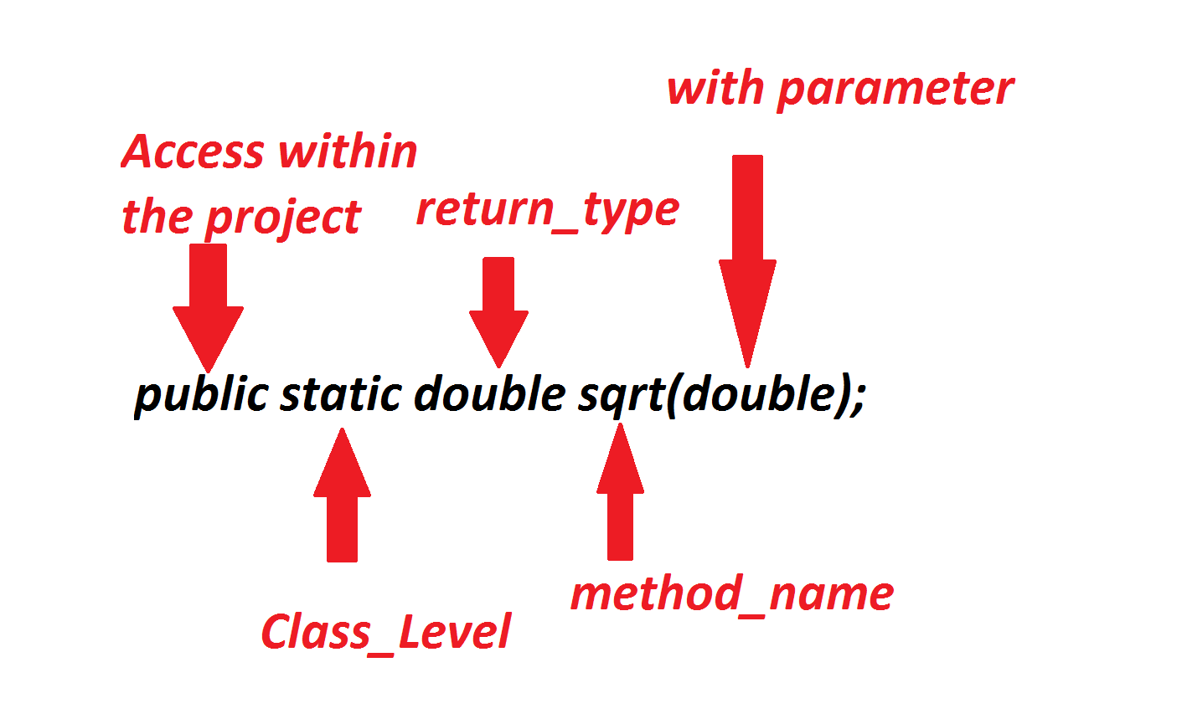

***Ex:***

***DemoImport.java***

***package maccess;***

***import java.util.Scanner;***

***import static java.lang.Math.*;***

***public class DemoImport {***

***public static void main(String[] args) {***

***Scanner s = new Scanner(System.in);***

***System.out.println("Enter the Value:");***

***double value = s.nextDouble();***

***double r = sqrt(value);//Method_call***

***System.out.println("Sqrt of "+value+" is "+r);***

***s.close();***

***}***

***}***

***o/p:***

***Enter the Value:***

***123***

***Sqrt of 123.0 is 11.090536506409418***

***==========================================================***

***\*imp***

***define Iterative Statements?***

***=>The statements which are used to execute some lines of program***

***repeated on some condition are known as Iterative statements or***

***Repeatitive Statements or Looping Structures.***

***=>The following are some important Iterative statements:***

***1.while loop***

***2.do-while loop***

***3.for loop***

***1.while loop:***

***=>In while looping structure the condition is checked first,***

***if the condition is true then the loop_body is executed and this***

***process is repeated until the condition is false.***

***syntax:***

***while(condition)***

***{***

***//loop_body***

***}***

***Flowchart:***

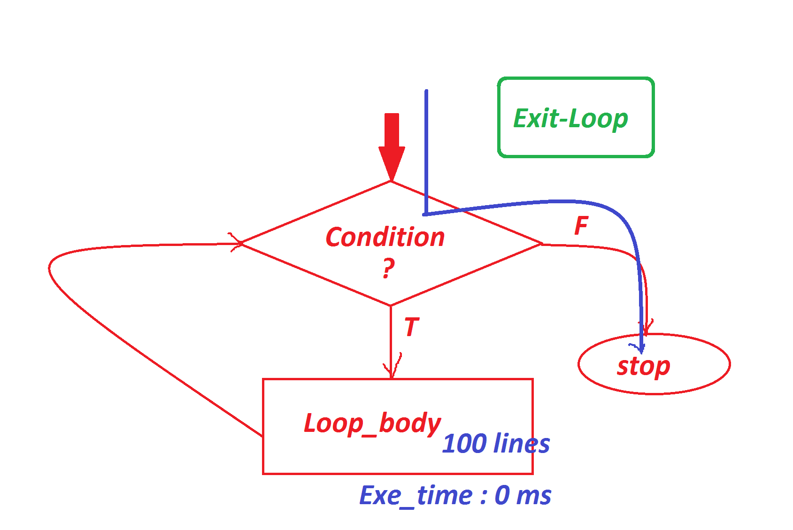

***----------------------------------------------------***

***2.do-while loop:***

***=>In do-while loop the loop_body is executed first,then the***

***condition is checked,and this process is repeated until the condition***

***is false.***

***syntax:***

***do***

***{***

***//loop_body***

***}***

***while(condition);***

***Flowchart:***

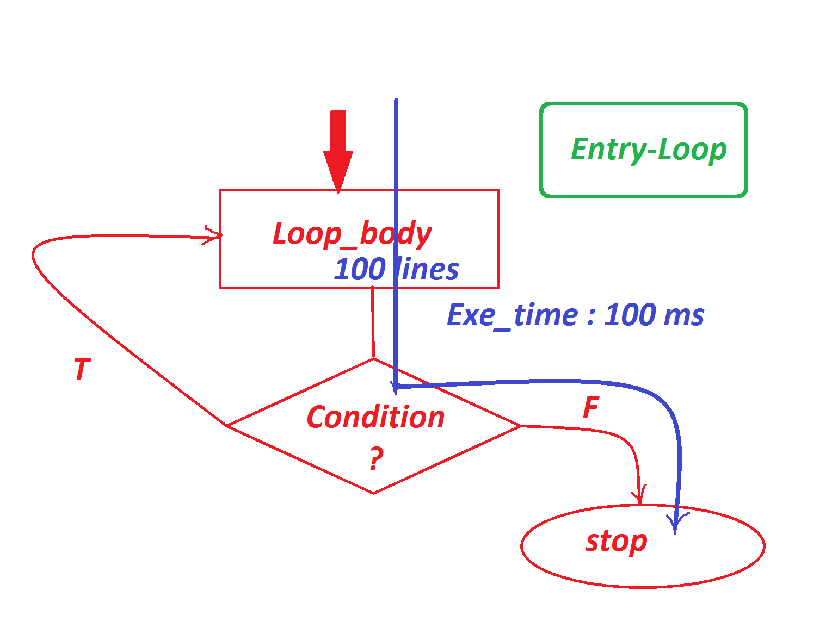

***------------------------------------------------------***

***Note:***

***=>In realtime do-while loop is less used when compared to while***

***loop,because in do-while loop the loop_body is executed once for***

***the false condition,and consumes execution time and degrades the***

***performance of an application.***

***=> while loop is also known as 'Exit-loop'.***

***=>do-while loop is also known as 'Entry-loop'.***

***============================================================***

***\*imp***

***3.for loop:***

***=>for loop is more simple in representation when compared to***

***while and do-while loops,because Initialization,Condition and***

***incre/Decre are declared in the same line.***

***syntax:***

***for(Initialization;Condition;Incre/Decre)***

***{***

***//loop_body***

***}***

***FlowChart:***

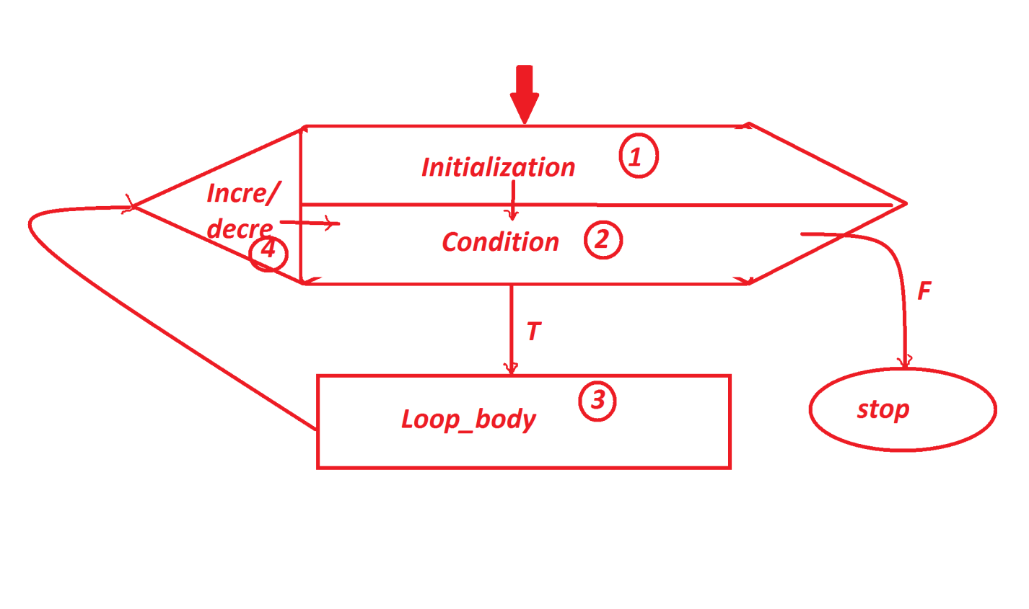

***============================================================***

***\*imp***

***Strings in Java:***

***=>The sequenced collection of characters which are represented in***

***double quotes is known as string.***

***Ex:***

***"nit","hyd","task",...***

***=>The characters in string are organized based on index values.***

***=>we use the following pre-defined classes from java.lang package***

***to create string objects:***

***1.java.lang.String class***

***2.java.lang.StringBuffer class***

***3.java.lang.StringBuilder class***

***Dt : 7/9/2022***

***1.java.lang.String class:***

***=>The Objects which are created using java.lang.String class are***

***'Immutable objects'.(The objects once created cannot be modified***

***are known as Immutable objects or Secured Objects or Constant***

***Objects)***

***=>'java.lang.String' class is holding 15 Constructors.***

***=>we use the following two syntaxes to create 'String' class objects:***

***syntax-1 : Using 'String literal process'***

***String name = "Raj";***

***String branch = "EEE";***

***syntax-2 : Using 'new operator process'***

***String ob1 = new String("VNR");***

***String ob2 = new String("Hyd");***

***Note:***

***=>Strings in java are not Arrays.***

***------------------------------------------------------------***

***Ex_Program-1 : wap to read and display String?***

***DemoString1 .java***

***package maccess;***

***import java.util.*;***

***public class DemoString1 {***

***public static void main(String[] args) {***

***Scanner s = new Scanner(System.in);***

***System.out.println("Enter the String:");***

***String str = s.nextLine();//String Literal process***

***int len = str.length();***

***System.out.println("====Using toString()====");***

***System.out.println(str.toString());***

***System.out.println("length:"+len);***

***System.out.println("===Display based on index value====");***

***for(int i=0;i<=len-1;i++)***

***{***

***char ch = str.charAt(i);***

***System.out.print(ch+" ");***

***}//end of loop***

***System.out.println("\n===Display String in reverse based on index===");***

***for(int i=len-1;i>=0;i--)***

***{***

***char ch = str.charAt(i);***

***System.out.print(ch+" ");***

***}***

***s.close();***

***}***

***}***

***o/p:***

***Enter the String:***

***program***

***====Using toString()====***

***program***

***length:7***

***===Display based on index value====***

***p r o g r a m***

***===Display String in reverse based on index===***

***m a r g o r p***

***Diagram:***

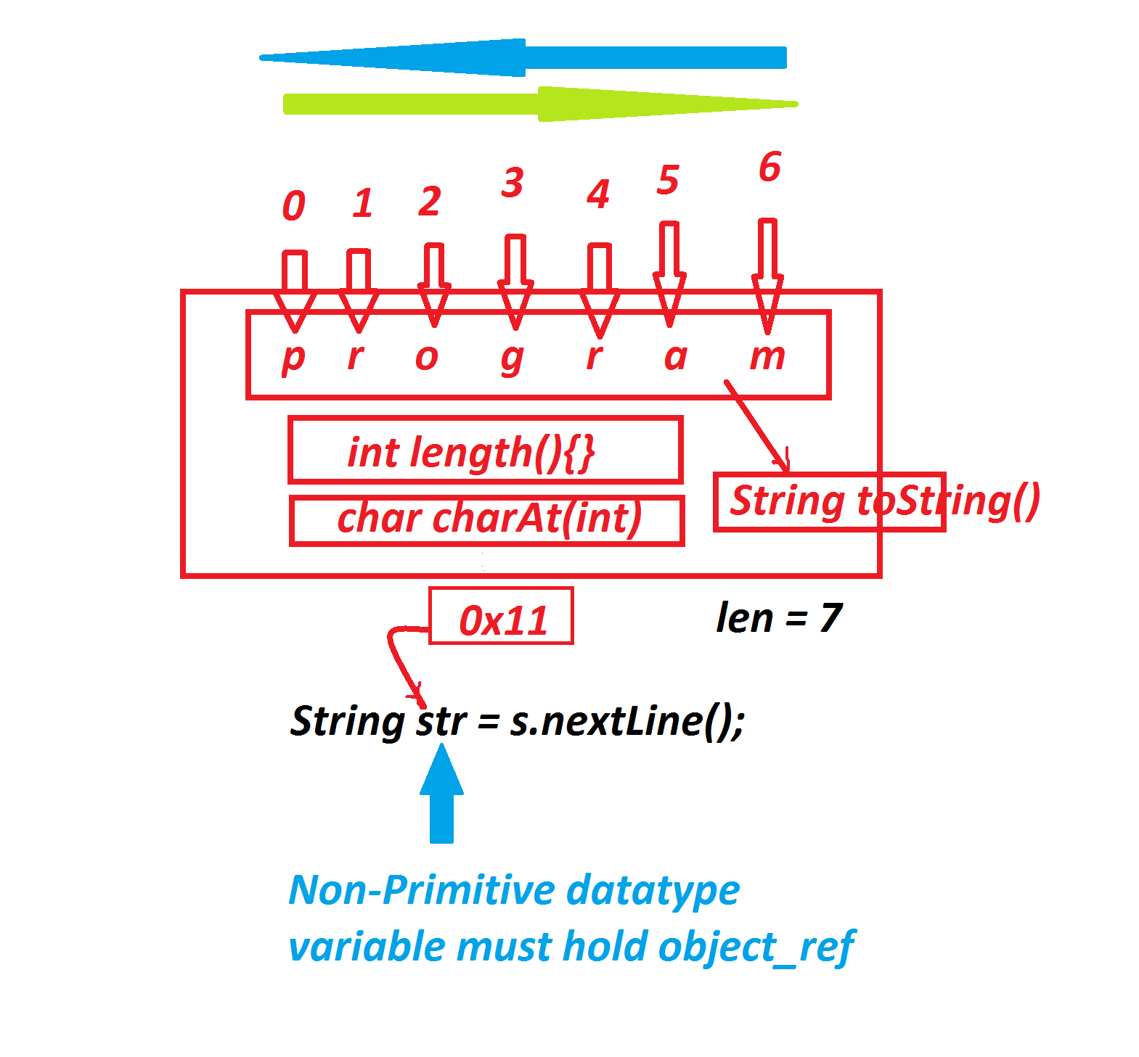

***=======================================================***

***EX_Program-2 : Wap to read a String and display the Count of vowels***

***from the given String?***

***DemoString2.java***

***package maccess;***

***import java.util.*;;***

***public class DemoString2 {***

***public static void main(String[] args) {***

***Scanner s = new Scanner(System.in);***

***System.out.println("Enter the String:");***

***String str = s.nextLine().toLowerCase();***

***int len = str.length();***

***int count=0;***

***for(int i=0;i<=len-1;i++)***

***{***

***char ch = str.charAt(i);***

***switch(ch)***

***{***

***case 'a':count++;***

***break;***

***case 'e':count++;***

***break;***

***case 'i':count++;***

***break;***

***case 'o':count++;***

***break;***

***case 'u':count++;***

***break;***

***}//end of switch***

***}//end of loop***

***System.out.println("Number of Vowels:"+count);***

***s.close();***

***}***

***}***

***o/p:***

***Enter the String:***

***program***

***Number of Vowels:2***

***========================================================***

***Assignment-1:***

***wap to read a String and check the String is Palindrome String or***

***not?***

***Note:***

***=>If the reverse of String is equal to the given String,then the***

***String is palindrome String.***

***Assignment-2:***

***wap to read a String and display the following:***

***Number of Vowels :***

***Number of Consonents :***

***Number of Numerics :***

***i/P : java18 by 2022***

***Vowels : 2***

***Consonents : 4***

***Numerics : 6***

***===================================================***